**Lesson 04 Demo 1**

**Using Measure names and Measure values**

**Business Scenario**:

A multinational retail chain is planning to launch its retail store. The chairman needs to analyze products currently being sold by the company. He should be able to quickly filter the data to examine various aspects of Product sales. Create a highlight table with the year, subcategory, and all the measures. Answer the following questions:

* What is the overall sales of the East region a couple of years back? (**Note**: Add a filter for the East region and add subtotals)
* What is the aggregated profit ratio for Binders four years back in the Central region?

(**Note**: Add a filter for the Central region).

**Overview:**

* Create a highlight table with year, subcategory, and all the measures
* Enable color legends per measure
* Apply a quick filter on measure names

The result should resemble the image given below:

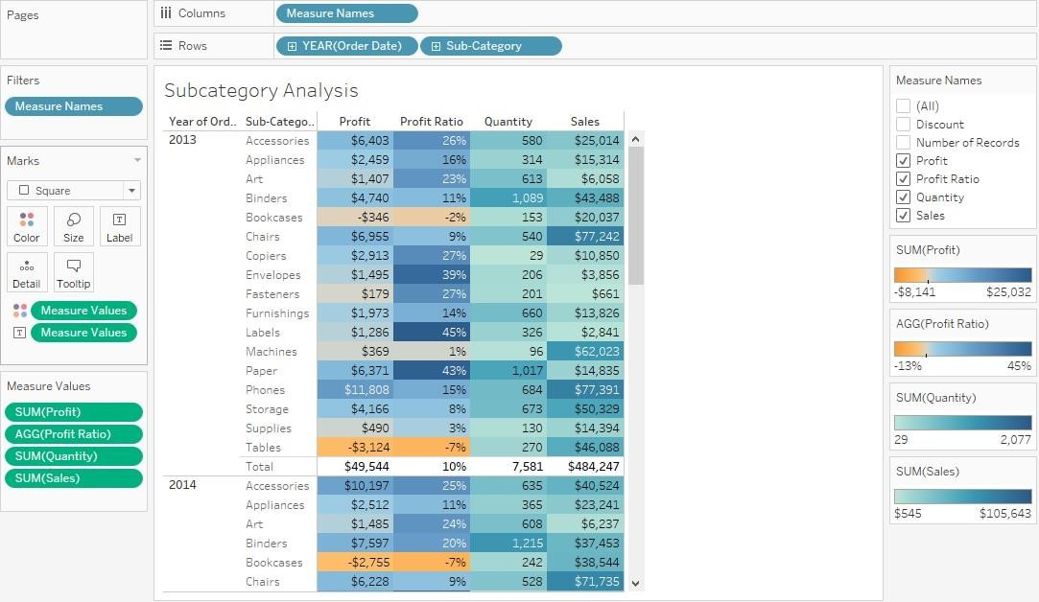

**Detailed Instructions:**

1. Open **Tableau 10.x** (You can go to Start Menu -> All Programs -> Tableau 2021.4)

1. From the home page, connect to the saved **Sample - Superstore** dataset

1. From Dimensions, drag **Order Date** and **Sub-Category** to the **Rows** shelf

1. From Dimensions, drag **Measure Names** to the **Columns** shelf

1. From Measures, drag **Measure Values** to **Text** shelf and **Color** Shelf in Marks card

1. To convert the view to a Highlight Table, change the **Marks** type to **Square**

1. To enable the filter, right-click on the **Measure Names** field in the **Columns** shelf and select **Show Filter**

**Note**: The Show Filter option shows the following window.

1. Uncheck **Count of Orders** and **Discount** in the show filter control

1. To add **Profit Ratio**, go to the **Analysis** pane and select **Create Calculated Field**

1. In the **Calculated Field** window, in the Name box, write **Profit Ratio,** and in the **Formula box**, type **SUM([Profit])/SUM([Sales])**

1. Click **OK**

1. Drag **Profit Ratio** to **Measure Values** under **SUM(Profit)**

1. Click on **AGG(Profit Ratio)** in **Measure Values** and select **Format**

1. In the **Pane** window, under **Default,** click on the drop-down of **Numbers,** select **Percentage,** and decrease the **Decimal** places to 0

1. In **Measure values,** click on **SUM(Profit)** and select **Format**

1. In the **Pane** window, under **Default**, click on **Numbers** drop-down, select **Currency (Standard)** drop-down, and change it to **English (United States)**

1. Select **Currency(Custom)** and decrease the **Decimal value** to 0

1. In **Measure Values,** click on **SUM(Sales)** and select **Format**

1. In the **Pane** window, under **Default**, click on **Numbers** drop-down, select **Currency (Standard)** drop-down, and change it to **English (United States)**

1. Select **Currency (Custom)** and decrease the **Decimal** value to 0

1. To enable color legends per measure, right-click on **Measure Values** in the **Color** shelf and select **Use Separate Legends**

**Note**: The Color Legends are enabled.

1. Rename the worksheet as **Subcategory Analysis**

**Note**: Keepthe workbook open for the next exercise.

**Answers:**

Based on the view, these are the answers to the questions in the problem statement:

* + What is the overall sales of the East region in2014?

Answer: **$128,680**

* + What is the aggregated profit ratio for Binders in 2016 in the Central region?

Answer: **21%**